Norris Bank Professional Learning Protocols and Inquiry Cycle

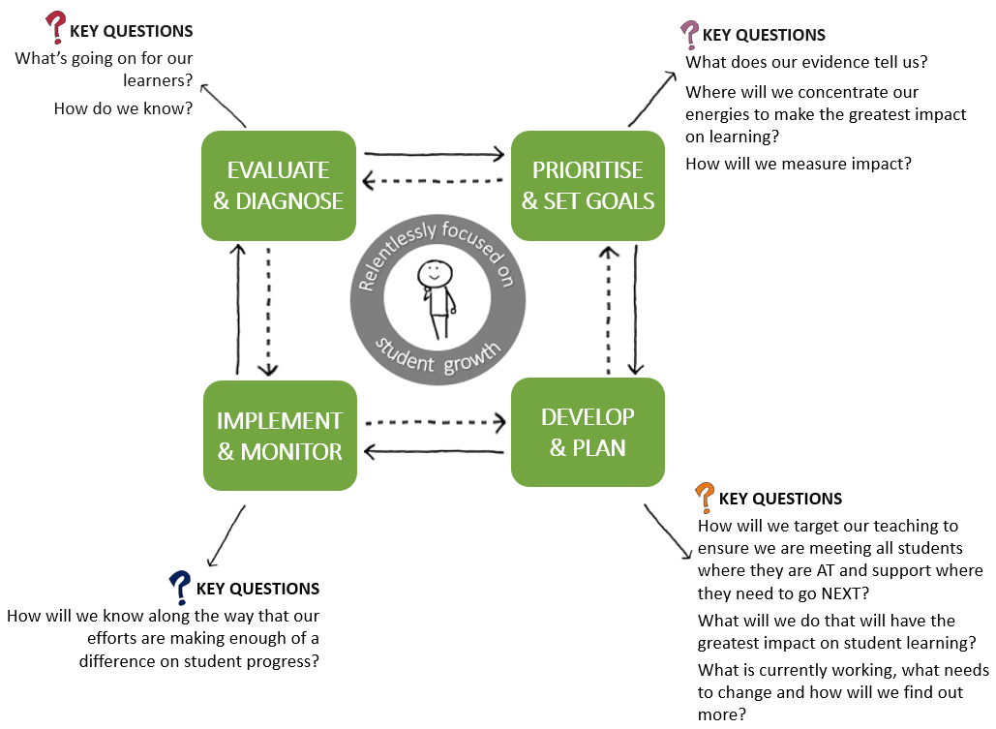

1. School leaders and teachers demonstrate a **commitment to school improvement** organised around **effective professional learning** e.g. disciplined collaboration, teachers as researchers and evaluators of

their own practice.

1. Professional learning is built into **daily practice** for example through classroom observation
2. Teacher learning needs are driven by the **learning needs of students**.
3. Responsibility for the learning of students is shared by all – **collective responsibility**.
4. All teachers believe that they can impact on student learning – **collective efficacy**.
5. **Leadership is distributed** so that professional learning leaders can contribute to a school focused on

learning.

1. **An inquiry cycle is central to the work** of teacher teams and, when used with a culture of challenge,

the inquiry facilitates evidenced-based change in practice.

1. Teachers are given **time** to meet regularly.